Tic-Tac-Toe Introduction

# Introduction:

Now that we have learned React for a bit we will start coding our **Tic-Tac-Toe** game. This will be kind of like a **completely new project** and will have multiple files in it.

The finished game will have the following features:

* Working game with no critical bugs
* Status showing which players turn it is
* Status showing the winner or a draw
* A button to clear the board if the game ends in a draw
* A button to play again after winner is announced
* A button to clear the board mid game
* A scoreboard which shows the number of games won by each player
* A button to clear the scoreboard

We will not add the components to our pages folder instead we will create new folder for the game under the src folder so it will be a bit easier to navigate. Let’s name it simply **tictactoe**:

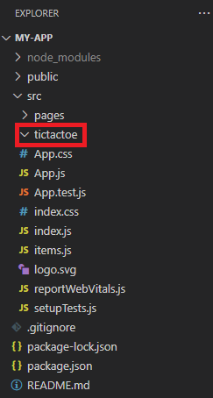

Here we will start the game in the first exercise where we will create the **base component** for the game. **See you there!** 😊